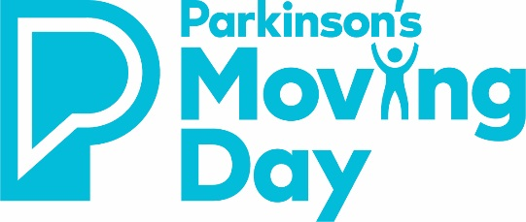
MOVING DAY SANTA FE
2024 VENDOR AGREEMENT

COMMITMENT LEVEL
☐ $250 - Resource Sponsor

Business Name:
Contact Name:
Street Address:
City: | State: | Zip:
Business Phone: | Email:
Web Address:
Authorized Signature: Date:

METHOD OF PAYMENT
All payments must be received within 30 days of signing this agreement.
☐ Credit Card or Wire Transfer: Call Robin Rhea at 480-506-0063 to pay the sponsorship fee with a credit card or via wire transfer.
☐ Check: Please make payable to Parkinson’s Foundation. See mailing address below.
☐ Please send invoice to: _________________________________________________________
☐ We are unable to be a Moving Day sponsor this year, but enclosed is our donation of $:_________
Email this letter of intent to: Robin R. Rhea
Mail check to: Parkinson’s Foundation/MD Santa Fe
24134 N. 165th Ave.
Surprise, AZ 85387

Please email an EPS logo and JPG logo to rrhea@parkinson.org by April 1st, 2023, to ensure high-quality printing.
If the partnership opportunities outlined in this package do not fit your marketing goals, please contact Robin R. Rhea to discuss other partnership opportunities.
Thank you for supporting the Parkinson’s Foundation!

